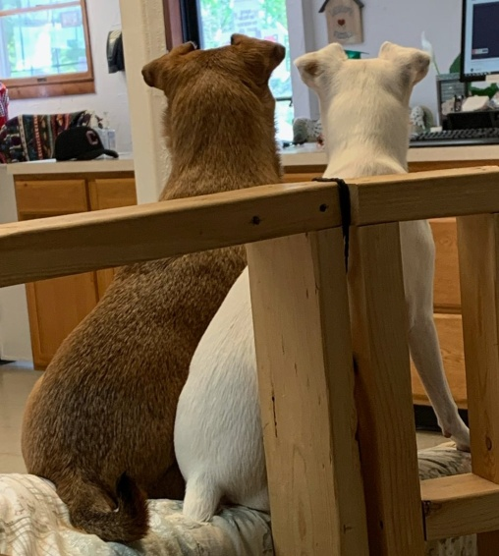
COME PLAY WITH US!!!

Taco and Willow can’t wait to greet you, and Jax wants to show you our new agility equipment! All our furry friends are ready to greet new buddies and welcome back all our old playmates! (Don’t miss out on the great savings below!)

